Example 3: Lock data in a table
Using functions to convert data can lead to problems, which data professionals must be prepared to fix. For example, if a reference value changes, the calculated value also changes. Locking data in a table by changing it from a function to a value ensures a cell stays consistent even if the data around it changes.
- Select cell F2. In the formula bar, notice that the contents of this cell are the function you entered in the previous example.
- Right-click cell F and select Copy from the drop-down menu.
- Right-click cell G and select Paste special from the drop-down menu. Then, select Paste values only. This option pastes only the values from the original selection, removing any formatting, functions, or other information.
- Select cell G2.
- In the formula bar, notice that the contents of this cell is a value. This means that the value won’t change when other cells change.

Convert data in spreadsheets
In this reading, you will learn about converting data from one format to another. One of the ways to help ensure that you have an accurate analysis of your data is by putting all of it in the correct format. This is true even if you have already cleaned and processed your data. As a part of getting your data ready for analysis, you will need to convert and format your data early on in the process.

As a data analyst, there are lots of scenarios when you might need to convert data in a spreadsheet:
String to date
- How to convert text to date in Excel: Transforming a series of numbers into dates is a common scenario you will encounter. This resource will help you learn how to use Excel functions to convert text and numbers to dates, and how to turn text strings into dates without a formula.
- Google Sheets: Change date format: If you are working with Google Sheets, this resource will demonstrate how to convert your text strings to dates and how to apply the different date formats available in Google Sheets.
String to numbers
- How to convert text to number in Excel: Even though you will have values in your spreadsheet that resemble numbers, they may not actually be numbers. This conversion is important because it will allow your numbers to add up and be used in formulas without errors in Excel.
- How to convert text to numbers in Google Sheets: This resource is useful if you are working in Google Sheets; it will demonstrate how to convert text strings to numbers in Google Sheets. It also includes multiple formulas you can apply to your own sheets, so you can find the method that works best for you.
Combining columns
- Convert text from two or more cells: Sometimes you may need to merge text from two or more cells. This Microsoft Support page guides you through two distinct ways you can accomplish this task without losing or altering your data. It also includes a step-by-step video tutorial to help guide you through the process.
- How to split or combine cells in Google Sheets: This guide will demonstrate how to to split or combine cells using Google Sheets specifically. If you are using Google Sheets, this is a useful resource to reference if you need to combine cells. It includes an example using real data.
Number to percentage
- Format numbers as percentages: Formatting numbers as percentages is a useful skill to have on any project. This Microsoft Support page will provide several techniques and tips for how to display your numbers as percentages.
- TO_PERCENT: This Google Sheets support page demonstrates how to use the TO_PERCENT formula to convert numbers to percentages. It also includes links to other formulas that can help you convert strings.
Pro tip: Keep in mind that you may have lots of columns of data that require different formats. Consistency is key, and best practice is to make sure an entire column has the same format.
Additional resources
If you find yourself needing to convert other types of data, you can find resources on Microsoft Support for Excel or Google Docs Editor Help for Google Sheets.
Converting data is quick and easy, and the same functions can be used again and again. You can also keep these links bookmarked for future use, so you will always have them ready in case any of these issues arise. Now that you know how to convert data, you are on your way to becoming a successful data analyst.
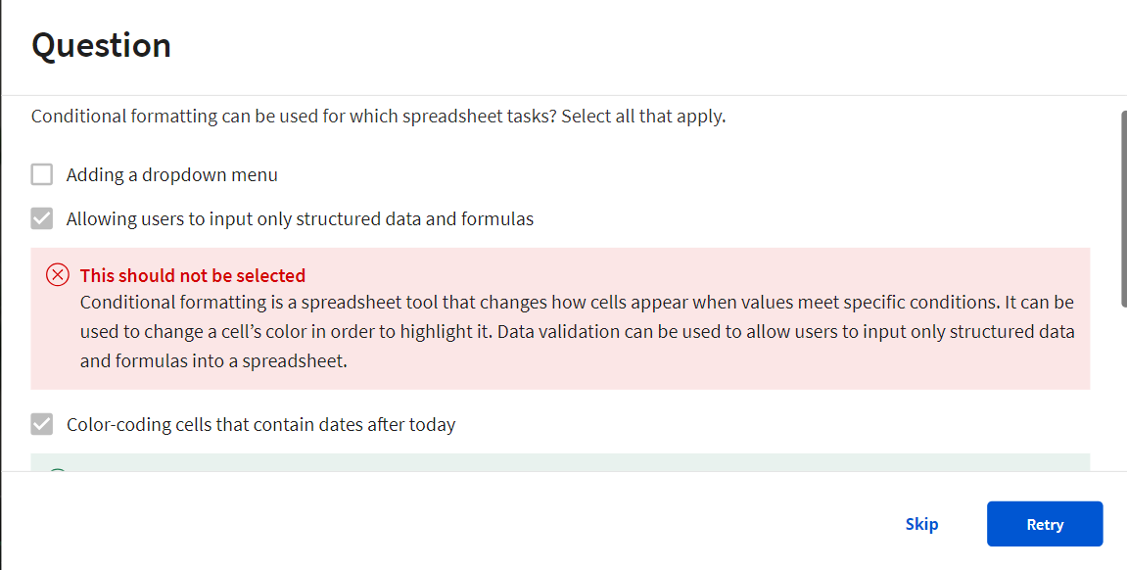
Transform data with SQL
Data analysts usually need to convert data from one format to another to complete an analysis. But what if you are using SQL rather than a spreadsheet? Just like spreadsheets, SQL uses standard rules to convert one type of data to another. If you are wondering why data transformation is an important skill to have as a data analyst, think of it like being a driver who is able to change a flat tire. Being able to convert data to the right format speeds you along in your analysis. You don’t have to wait for someone else to convert the data for you.

In this reading, you will go over the conversions that can be done using the CAST function. There are also more specialized functions like COERCION to work with big numbers, and UNIX_DATE to work with dates. UNIX_DATE returns the number of days that have passed since January 1, 1970 and is used to compare and work with dates across multiple time zones. You will likely use CAST most often.
Common conversions
The following table summarizes some of the more common conversions made with the CAST function. Refer to Conversion Rules in Standard SQL for a full list of functions and associated rules.
Starting with | CAST function can convert to:
Numeric (number) | - Integer - Numeric (number) - Big number - Floating integer - String
String | - Boolean - Integer - Numeric (number) - Big number - Floating integer - String - Bytes - Date - Date time - Time - Timestamp
Date | - String - Date - Date time - Timestamp
The CAST function (syntax and examples)
CAST is an American National Standards Institute (ANSI) function used in lots of programming languages, including BigQuery. This section provides the BigQuery syntax and examples of converting the data types in the first column of the previous table. The syntax for the CAST function is as follows:
1
CAST(expression AS typename)
Where expression is the data to be converted and typename is the data type to be returned.
Converting a number to a string
The following CAST statement returns a string from a numeric identified by the variable MyCount in the table called MyTable.
1
SELECT CAST(MyCount AS STRING) FROM MyTable
In the above SQL statement, the following occurs:
- SELECT indicates that you will be selecting data from a table
- CAST indicates that you will be converting the data you select to a different data type
- AS comes before and identifies the data type which you are casting to
- STRING indicates that you are converting the data to a string
- FROM indicates which table you are selecting the data from
Converting a string to a number
The following CAST statement returns an integer from a string identified by the variable MyVarcharCol in the table called MyTable. (An integer is any whole number.)
1
SELECT CAST(MyVarcharCol AS INT) FROM MyTable
In the above SQL statement, the following occurs:
- SELECT indicates that you will be selecting data from a table
- CAST indicates that you will be converting the data you select to a different data type
- AS comes before and identifies the data type which you are casting to
- INT indicates that you are converting the data to an integer
- FROM indicates which table you are selecting the data from
Converting a date to a string
The following CAST statement returns a string from a date identified by the variable MyDate in the table called MyTable.
1
SELECT CAST(MyDate AS STRING) FROM MyTable
In the above SQL statement, the following occurs:
- SELECT indicates that you will be selecting data from a table
- CAST indicates that you will be converting the data you select to a different data type
- AS comes before and identifies the data type which you are casting to
- STRING indicates that you are converting the data to a string
- FROM indicates which table you are selecting the data from
Converting a date to a datetime
Datetime values have the format of YYYY-MM-DD hh: mm: ss format, so date and time are retained together. The following CAST statement returns a datetime value from a date.
1
SELECT CAST (MyDate AS DATETIME) FROM MyTable
In the above SQL statement, the following occurs:
- SELECT indicates that you will be selecting data from a table
- CAST indicates that you will be converting the data you select to a different data type
- AS comes before and identifies the data type which you are casting to
- DATETIME indicates that you are converting the data to a datetime value
- FROM indicates which table you are selecting the data from
The SAFE_CAST function
Using the CAST function in a query that fails returns an error in BigQuery. To avoid errors in the event of a failed query, use the SAFE_CAST function instead. The SAFE_CAST function returns a value of Null instead of an error when a query fails.
The syntax for SAFE_CAST is the same as for CAST. Simply substitute the function directly in your queries. The following SAFE_CAST statement returns a string from a date.
1
SELECT SAFE_CAST(MyDate AS STRING) FROM MyTable
More information
Browse these resources for more information about data conversion using other SQL dialects (instead of BigQuery):
- CAST and CONVERT: SQL Server reference documentation
- MySQL CAST Functions and Operators: MySQL reference documentation
- How to: SQL Type Casting: Blog about type casting that has links to other SQL short guides
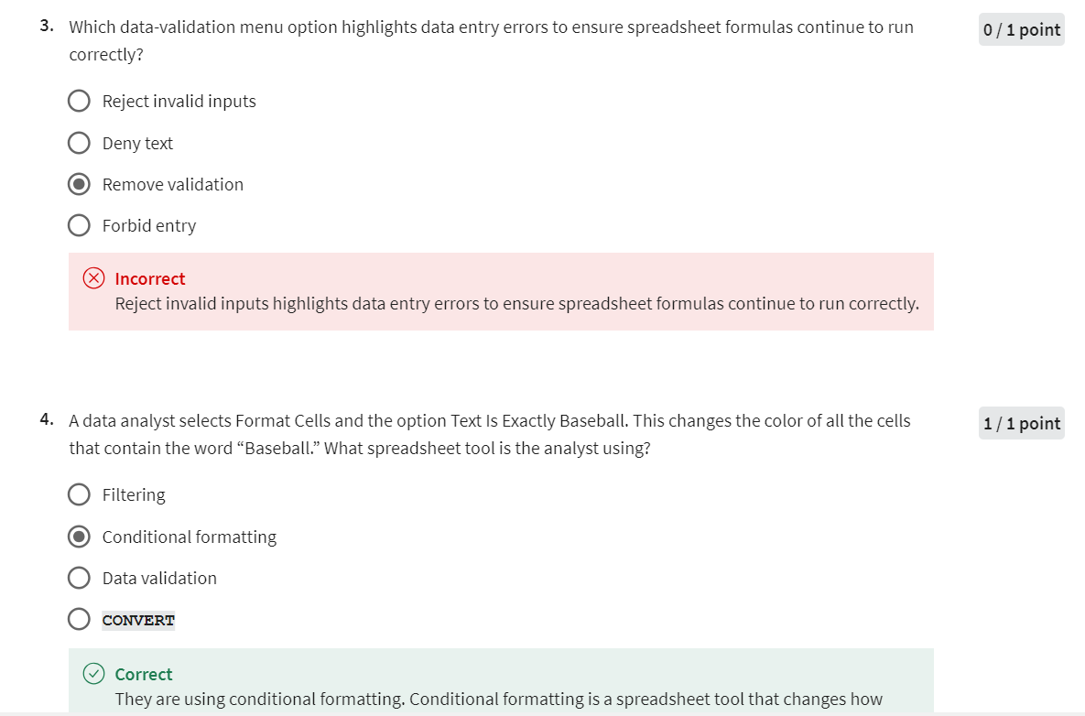

Import and combine data in spreadsheets and databases
In earlier lessons, you discovered how to use the IMPORTRANGE and CONCATENATE functions in spreadsheets. In this reading, you will have the opportunity to extend your knowledge about these concepts to SQL queries.
Import data
As a data analyst, there are many occasions where you will need to import data from one file or location to another. Both spreadsheets and SQL include functionality that enables you to import data.
Import data in spreadsheets
As you learned earlier, in spreadsheets you use the IMPORTRANGE function to import a range of cells from another spreadsheet into your current spreadsheet. The syntax is: =IMPORTRANGE(spreadsheet_url, range_string).
In this formula, spreadsheet_url is the URL of the spreadsheet from which you want to import data. The specific cells you want to import, such as A2:B6, are specified by range_string. If the spreadsheet has multiple tabs, you also need to specify the name of the tab as part of the range.
An example of this is a company that needs to track who made retirement contributions so that it can make sure the company match is correctly distributed. The analysts would use IMPORTRANGE to pull all retirement contribution information into a spreadsheet that contains all of the employees year-end salaries and bonuses. This enables them to determine which employees made contributions and are eligible for matching funds.
Import data in SQL
In contrast to spreadsheets, SQL does not include a function for importing data. Instead, a method you can use to import data from one table to another is to use the INSERT INTO command together with a SELECT statement. The syntax is:
4
3
1
2
WHERE [condition]
FROM [source_table_name]
INSERT INTO [destination_table_name]
SELECT [column names, separated by commas, or * for all columns]
In this syntax, the SQL query inserts rows from a source table into a destination table based on the WHERE clause.
For example, imagine you work for a retail company that stores its sales and customer information in a SQL database. The marketing director asks you to provide them with a table containing the names and addresses of customers who have not made a purchase this year and who live in specific postal codes. One way you could gather this information is to use the INSERT INTO along with the SELECT and WHERE commands, as follows:
4
1
2
3
WHERE total_sales = 0 AND postal_code = '12345'
INSERT INTO customer_promotion
SELECT *
FROM customers
Combine data
Another tool in your data analyst toolkit is your ability to join together two or more text strings that are stored in separate columns or fields. For example, you might want to combine a customer’s first and last name to create mailing labels for a marketing promotion. In both spreadsheets and SQL, joining together text strings is referred to as concatenation.

Combine data in spreadsheets
In spreadsheets, you use the CONCATENATE function to join together two or more text strings, such as combining street addresses and primary contacts in a business’ vendor database.
The basic syntax is =CONCATENATE(item 1, item 2). You can add multiple items by separating them with commas. Where appropriate, such as when you’re combining a customer’s first and last name, you should add a space between the items you’re combining by typing quotation marks space quotation marks [“ ”] between the items. Separate this information by a comma as well. This would change the formula to: =CONCATENATE(item 1, " ", item 2).
Combine data in SQL
In SQL, use the CONCAT function to join strings together to create new text strings. You might combine data simply to improve the readability of reports (such as combining a customer’s first and last name when generating a customer list). Or, you might combine data to generate a unique identifier for the rows in a table. Here is the basic syntax:
2
FROM [table_name]
Notice that this syntax includes " " so that there is a space between the combined fields. With this syntax, SQL combines field1 and field2 with a space between them.
By default, SQL includes the field names as headers when you run a query. However, if you use the CONCAT function, SQL doesn’t know what to use as a header. For this reason, you should include an alias for the combined fields to help with readability. You give the combined fields an alias by using AS:
2
1
FROM [table_name]
SELECT CONCAT(field1, " ", field2) AS alias
For example, if you plan to use CONCAT to combine the first and last names of your company’s customers into a single expression, you could use this query:
1
2
SELECT CONCAT(first_name, " ", last_name) AS Customer_Name
FROM [table_name]
Key takeaways
Data can be imported and combined in both spreadsheets and SQL databases. To import data into a spreadsheet, use the IMPORTRANGE function. To import data into a SQL table, use the INSERT INTO, SELECT, and WHERE commands. Use CONCATENATE to combine two or more data strings in spreadsheets. In SQL, use the CONCAT function to combine fields.

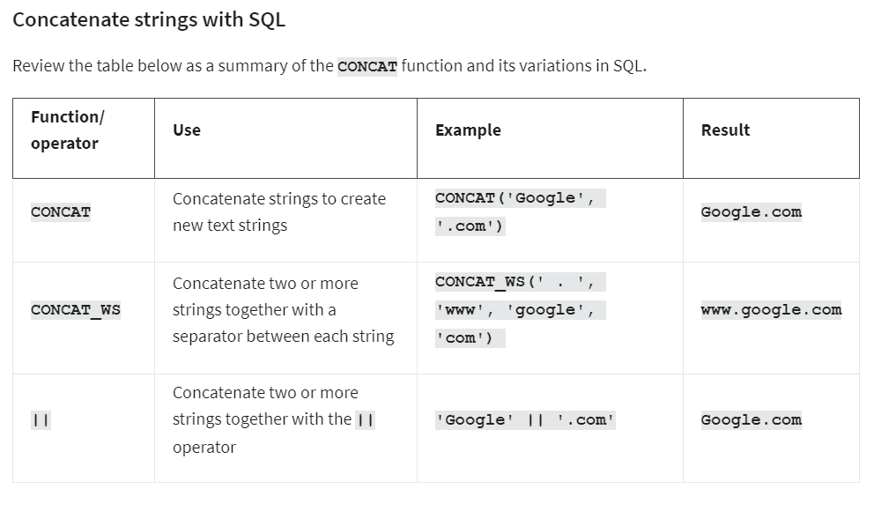
Advanced spreadsheet tips and tricks
Like a lot of the things you’re learning in this program, spreadsheets will get easier the more you practice. This reading provides you with a list of resources that may help advance your knowledge and experience with spreadsheet functions and functionality. The goal is to provide you with access to a variety of advanced tips and tricks that will help make you more efficient and effective when working with spreadsheets to perform data analysis. Review the description of each resource below, click the links to learn more, and save or bookmark any links that are useful to you. You can immediately start practicing anything that you learn to increase the chances of your understanding and to build your familiarity with spreadsheets. This reading provides a range of resources, so feel free to explore the ones that are applicable to you and skip the ones that aren’t.
Google Sheets
- Keyboard shortcuts for Google Sheets: This is a great resource for quickly learning a range of keyboard shortcuts that can make regular tasks quicker and easier, like navigating your spreadsheet or accessing formulas and functions. This list contains shortcuts for the desktop and mobile versions of Google Sheets so that you can apply them to your work no matter what device you are using.
- List of Google Sheets Functions: This is a comprehensive list of the Google Sheets functions and syntax. Each function is listed with a link to learn more.
- 23 Must-Know Google Sheet Formulas: This blog article from Layer summarizes and describes 20 of the most useful Google Sheets formulas.
- 18 Google Sheets Formula Tips and Techniques: These are tips for using Google Sheets shortcuts when working with formulas.
Excel
- Keyboard shortcuts in Excel: Earlier in this list, you were provided with a resource for keyboard shortcuts in Google Sheets. Similarly, this resource provides a list of keyboard shortcuts in Excel that will make performing regular spreadsheet tasks more efficient. This includes keyboard shortcuts for both desktop and mobile versions of Excel, so you can apply them no matter what platform you are working on.
- 222 Excel shortcuts: A compilation of shortcuts includes links to more detailed explanations about how to use them. This is a great way to quickly reference keyboard shortcuts. The list has been organized by functionality, so you can go directly to the sections that are most useful to you.
- List of spreadsheet functions: This is a comprehensive list of Excel spreadsheet functions with links to more detailed explanations. This is a useful resource to save so that you can reference it often; that way, you’ll have access to functions and examples that you can apply to your work.
- List of spreadsheet formulas: Similar to the previous resource, this comprehensive list of Excel spreadsheet formulas with links to more detailed explanations and can be saved and referenced any time you need to check out a formula for your analysis.
- Essential Excel Skills for Analyzing Data: This blog post includes more advanced functionalities of some spreadsheet tools that you have previously learned about, like pivot tables and conditional formatting. These skills have been identified as particularly useful for data analysis. Each section includes a how-to video that will take you through the process of using these functions step-by-step, so that you can apply them to your own analysis.
- Advanced Spreadsheet Skills: Mark Jhon C. Oxillo’s presentation starts with a basic overview of spreadsheet but also includes advanced functions and exercises to help you apply formulas to actual data in Excel. This is a great way to review some basic concepts and practice the skills you have been learning so far.
There are lots of resources online about advanced spreadsheet tips and tricks. You'll probably discover new resources and tools on your own, but this list is a great starting point as you become more familiar with spreadsheets.

